Studio

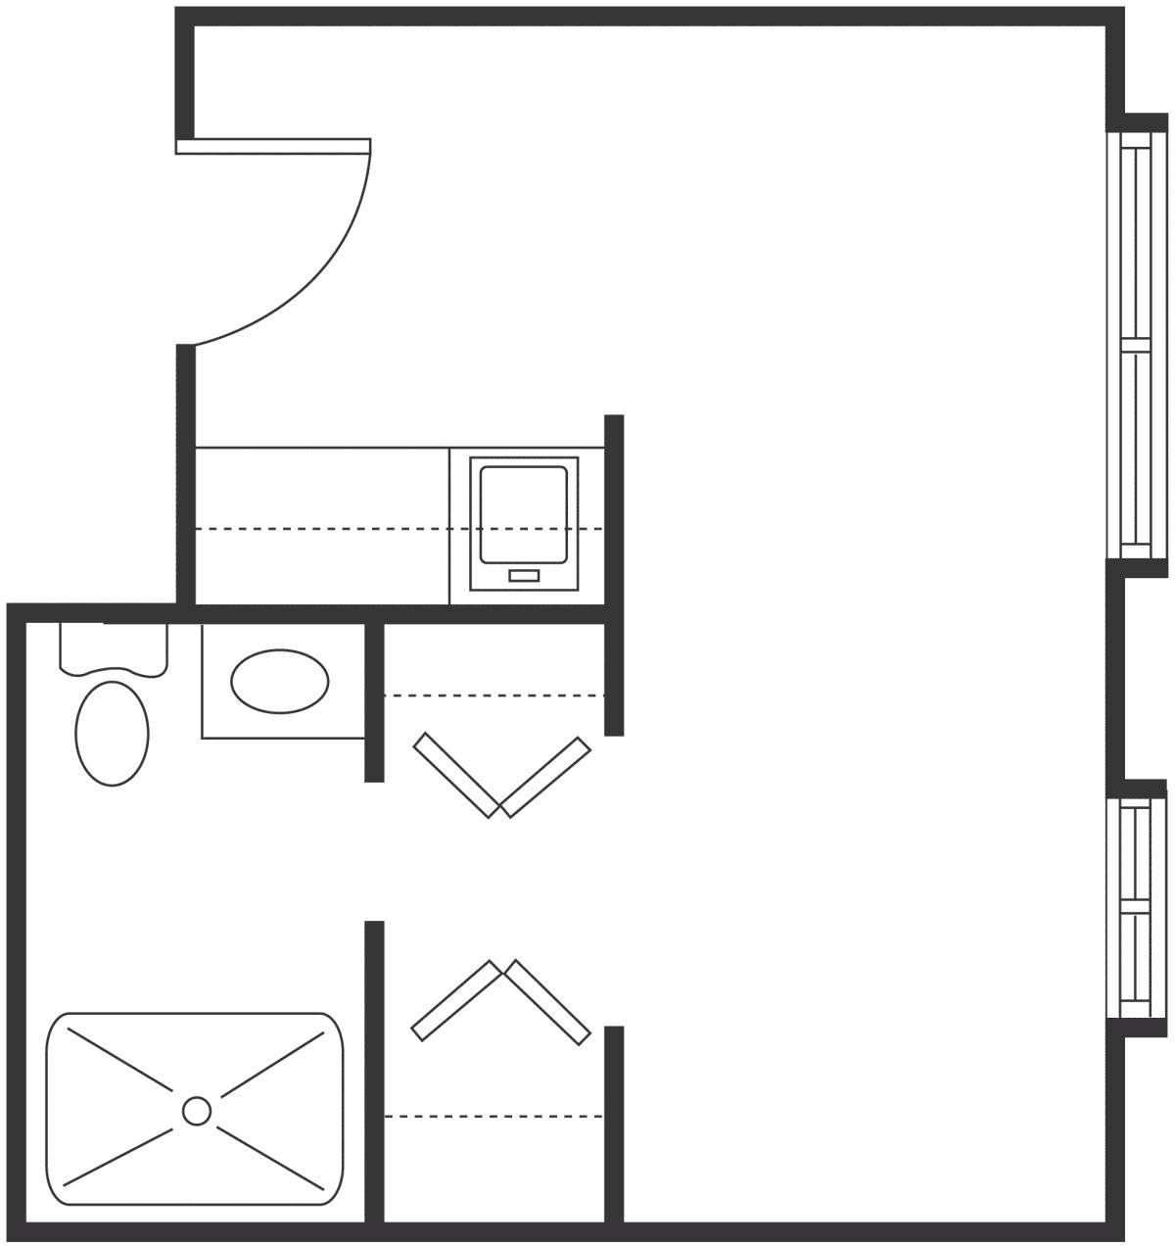

Studio
One Bath
280 Square Feet (approximately)

One Bedroom

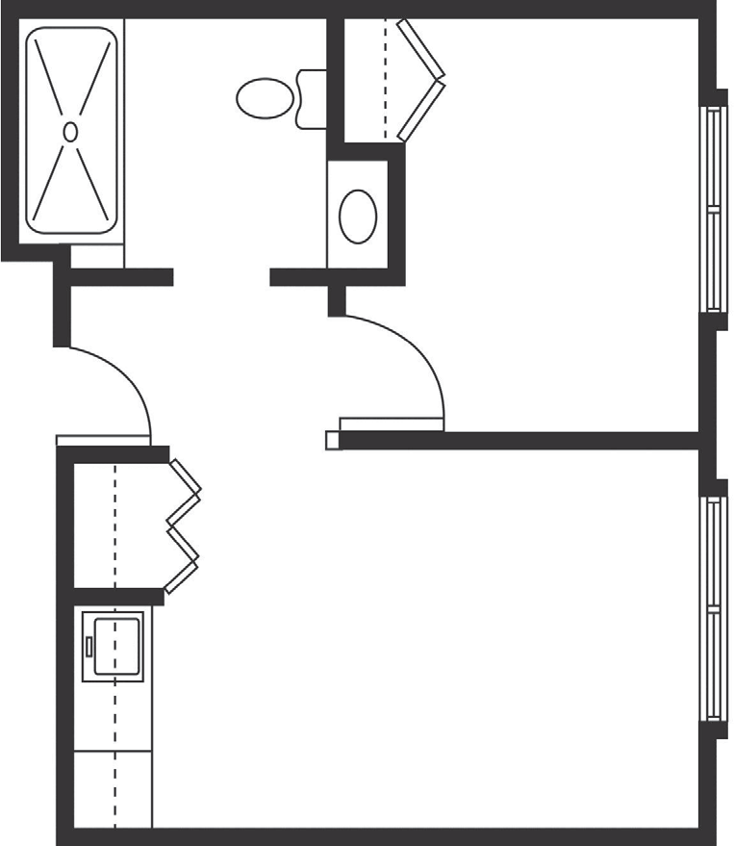

One Bedroom
One Bedroom / One Bath
406 Square Feet (approximately)

