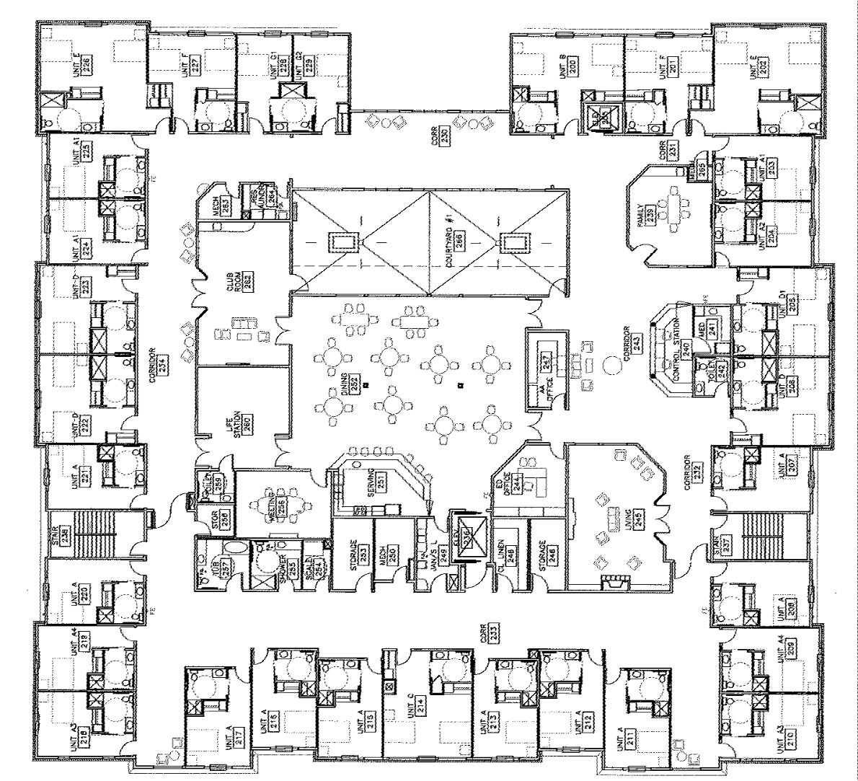

2nd Floor Plan

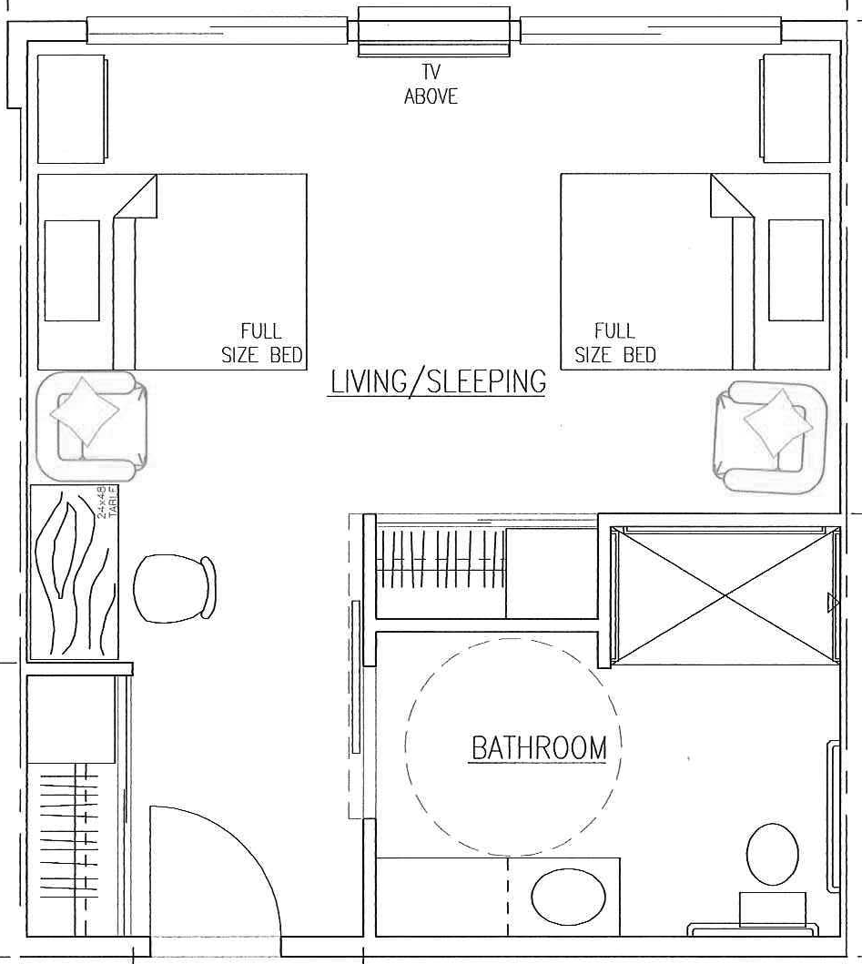

Companion Suite
409 Square Feet Unit D

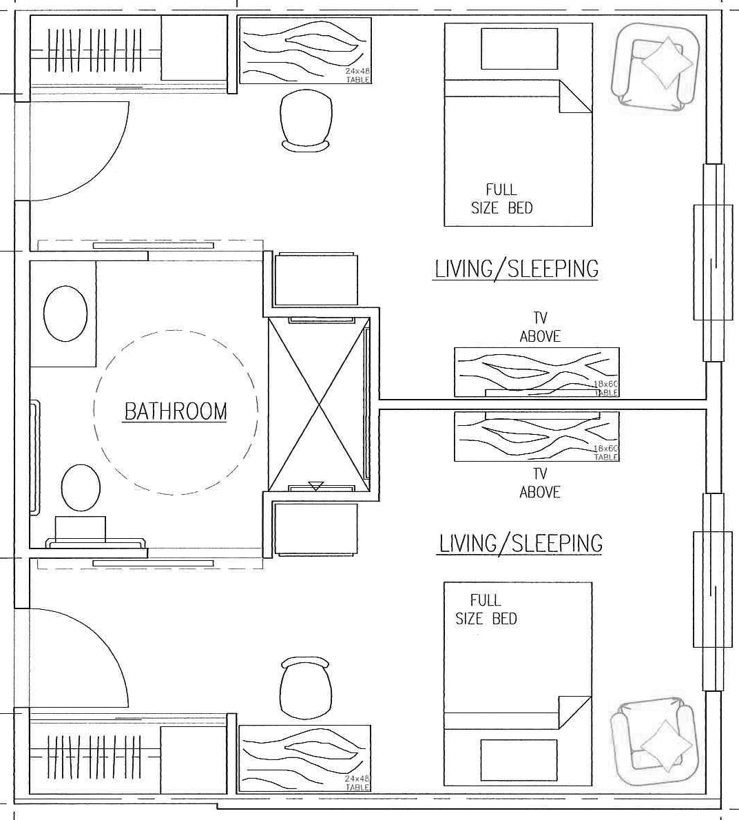

Neighbor Suite
514 Square Feet Unit G

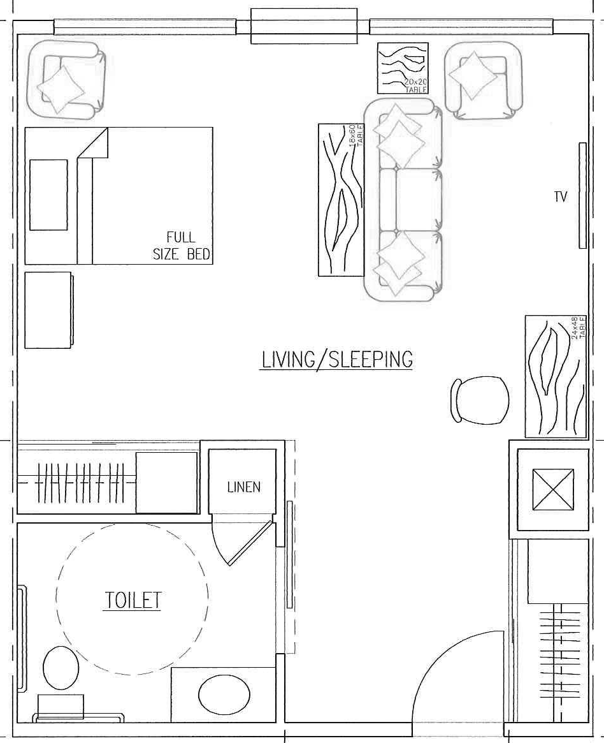
POWDER ROOM

Private Suite
448 Square Feet Unit C

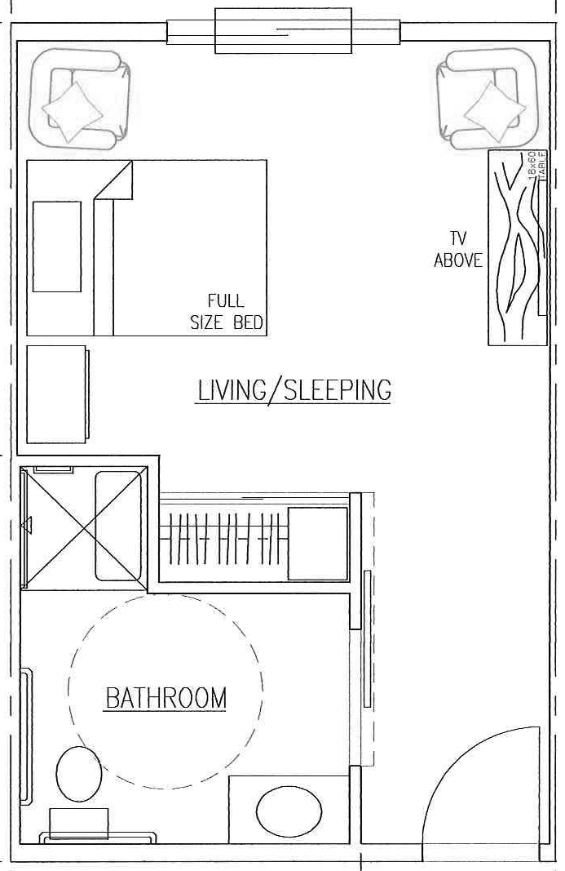

Private Suite
301 Square Feet Unit A

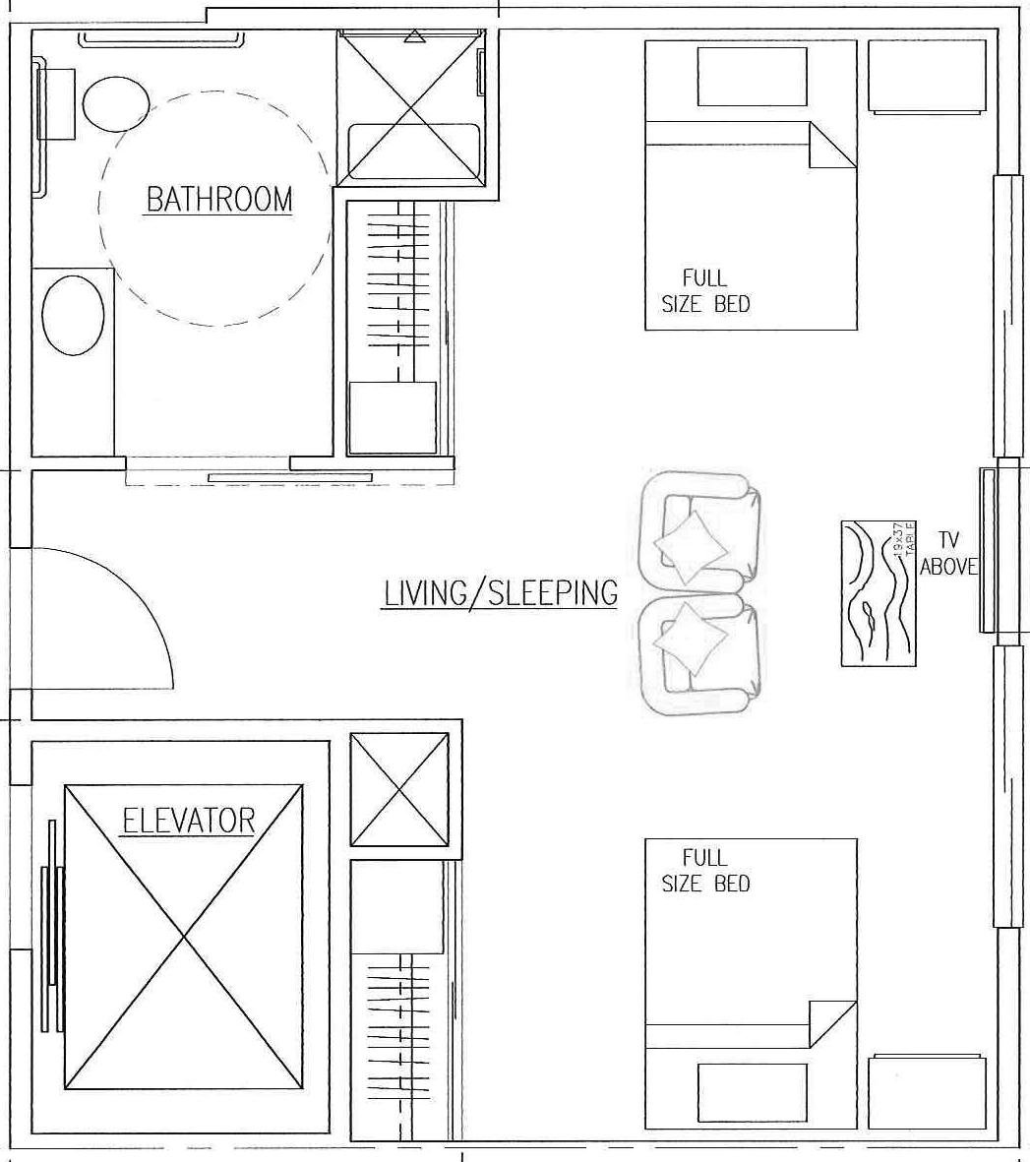

Companion Suite
457 Square Feet Unit B

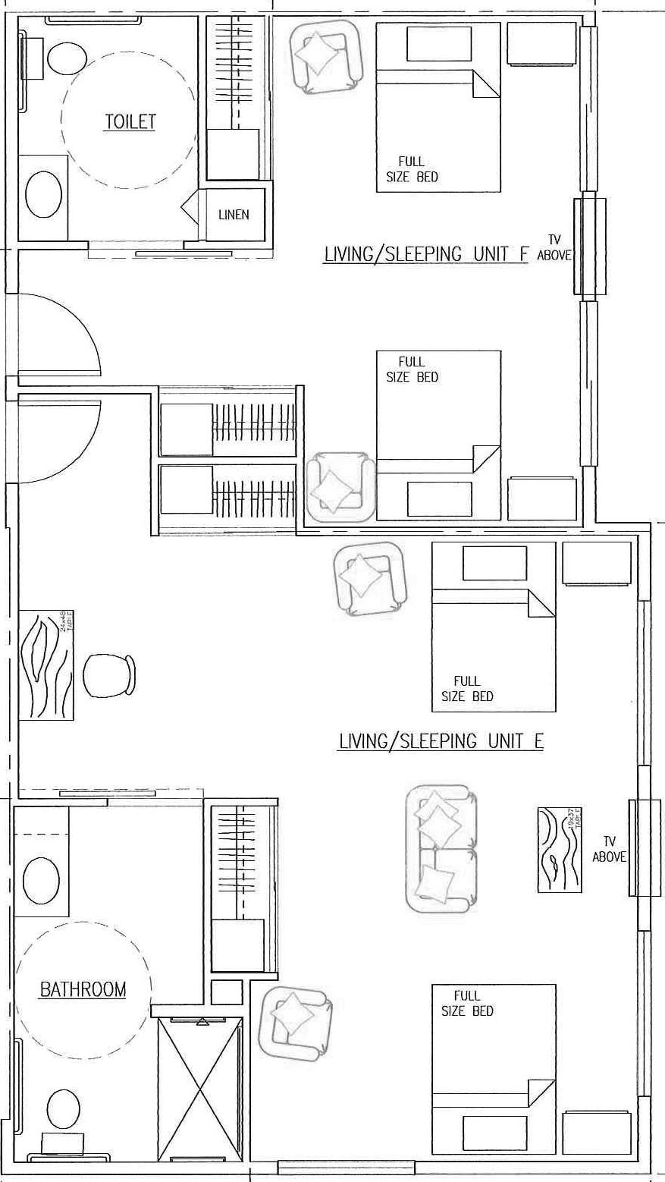

Companion Suite
577 Square Foot Unit E • 376 Square Foot Unit F

